Mathematical Morphology Report

Visual Data 18-12-2019

Ankit Rathi

Uwacu Jean Remy

1. Load the rectangle image –

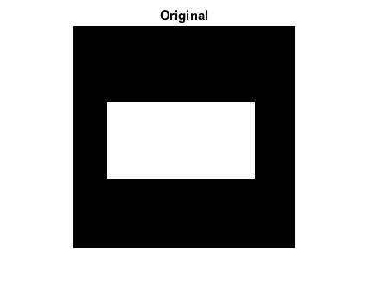

1. Perform dilation and erosion with squared structing element of size (10*10,30*30,50*50)

In [mathematical morphology](https://en.wikipedia.org/wiki/Mathematical_morphology) and [digital image processing](https://en.wikipedia.org/wiki/Digital_image_processing), a **morphological gradient** is the difference between the [dilation](https://en.wikipedia.org/wiki/Dilation_(morphology)) and the [erosion](https://en.wikipedia.org/wiki/Erosion_(morphology)) of a given image. It is an image where each [pixel](https://en.wikipedia.org/wiki/Pixel) value (typically non-negative) indicates the contrast intensity in the close neighborhood of that pixel. It is useful for [edge detection](https://en.wikipedia.org/wiki/Edge_detection) and [segmentation](https://en.wikipedia.org/wiki/Segmentation_(image_processing)) applications.

1. Dilation –

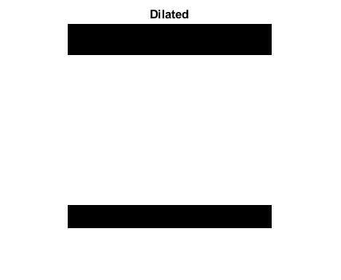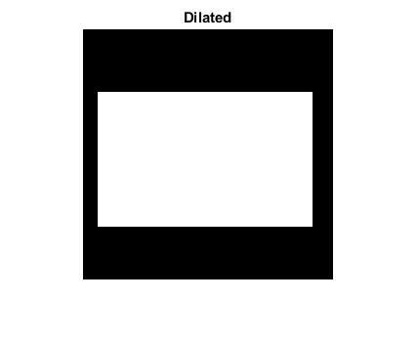

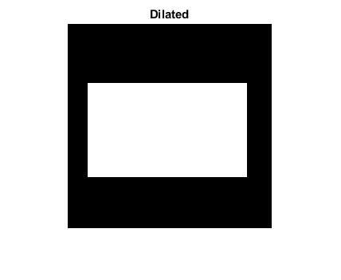

1. Eroded image –



Comment -- **Dilation** adds pixels to the boundaries of objects in an image, while **erosion** removes pixels on object boundaries. The number of pixels added or removed from the objects in an image depends on the **size** and shape of the **structuring element** used to process the image.

An essential part of the morphological dilation and erosion operations is the structuring element used to probe the input image. A structuring element is a matrix that identifies the pixel in the image being processed and defines the neighborhood used in the processing of each pixel. You typically choose a structuring element the same size and shape as the objects you want to process in the input image.

So, As the size changes from 10*10 to 30*30 we can see the changes in pixels as well.

1. Detect edges
2. Internal –





1. External—





1. Total gradient –



The **internal gradient** enhances **internal** boundaries of objects brighter than their background and external boundaries of objects darker than their background. For binary images, the **internal gradient** generates a mask of the **internal** boundaries of the foreground image objects.

An **image gradient** is a directional change in the intensity or color in an image. The gradient of the image is one of the fundamental building blocks in [image processing](https://en.wikipedia.org/wiki/Image_processing). For example, the [Canny edge detector](https://en.wikipedia.org/wiki/Canny_edge_detector) uses image gradient for [edge detection](https://en.wikipedia.org/wiki/Edge_detection). In [graphics software](https://en.wikipedia.org/wiki/Graphics_software) for [digital image editing](https://en.wikipedia.org/wiki/Digital_image_editing), the term gradient or [color gradient](https://en.wikipedia.org/wiki/Color_gradient) is also used for a gradual blend of [color](https://en.wikipedia.org/wiki/Color) which can be considered as an even [gradation](https://en.wiktionary.org/wiki/gradation) from low to high values, as used from white to black in the images to the right. Another name for this is *color progression*.

1. Load art4.png and wdg2th.png image

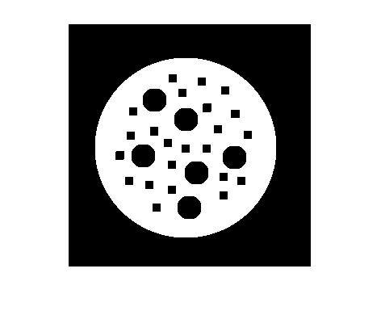

Perform closing –



[J](https://www.mathworks.com/help/images/ref/imclose.html#d117e137308) = imclose([I](https://www.mathworks.com/help/images/ref/imclose.html#d117e137171),[SE](https://www.mathworks.com/help/images/ref/imclose.html#d117e137226)) performs morphological closing on the grayscale or binary image I, returning the closed image, J. SE is a single structuring element object returned by the [strel](https://www.mathworks.com/help/images/ref/strel.html) or [offsetstrel](https://www.mathworks.com/help/images/ref/offsetstrel.html) functions. The morphological close operation is a dilation followed by an erosion, using the same structuring element for both operations.

You optionally can perform the morphological closing using a GPU

1. Load image art3.png and remove all the lines present –
2. Remove all the lines –



1. How does it works?

What Is the meaning of structing element ?

A **structuring element** is a matrix that identifies the pixel in the image being processed and defines the neighborhood used in the processing of each pixel. You typically choose a **structuring element** the same size and shape as the objects you want to process in the input image

Adjust proper structing element to close the holes ?

One of the uses of dilation is to fill in small background color **holes** in images, e.g. ... To achieve the effect of **a closing** with **a** larger **structuring element**, **it** is ... Whether or not this can be done depends upon whether **a suitable structuring element** ... that are to be preserved, but doesn't **fit** inside regions that are to be removed.

1. Bwmorph (skeleton)

Read binary image and display it.

Remove interior pixels to leave an outline of the shapes.

Get the image skeleton.

We are working on images present in skeleton folder in this task ---

First we load all the images and after that we perform our task.

Art6.png

Original image



Bwmorph image –

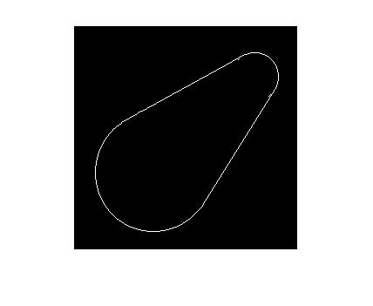

Skelton image –

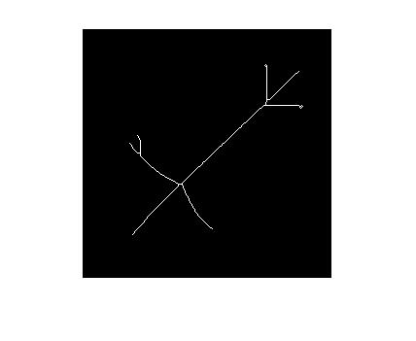

Art5cha.png –

Original image –



Bwmorph image –

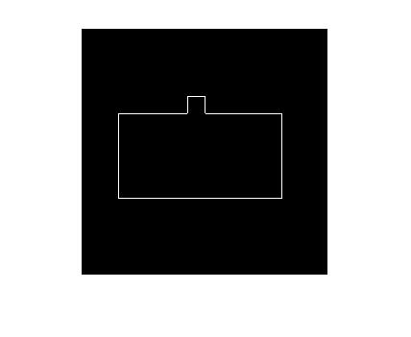

Skeleton image—

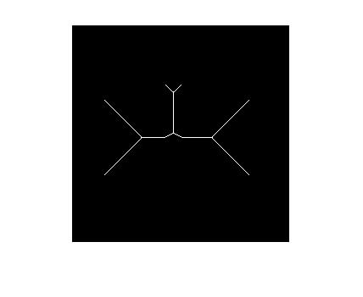

Rlf1.png ---

Original image –

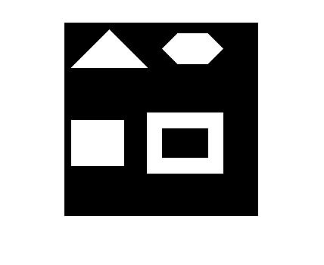

Bwmorph image—

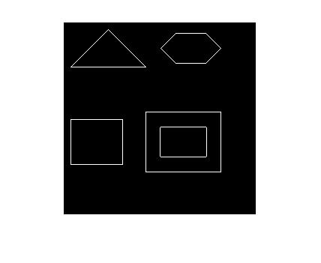

Skeleton image –

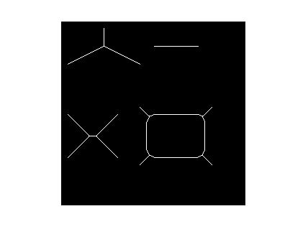

9. perform thickening on image in thickening folder –

Read binary image and display it.

Remove interior pixels to leave an outline of the shapes.

Get the image Thickening.

a. Load images art8.png and phn1thr1.png and perform operation on them

Art8original –



Bwmorph –

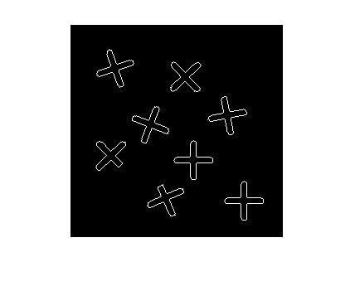

Thickening –

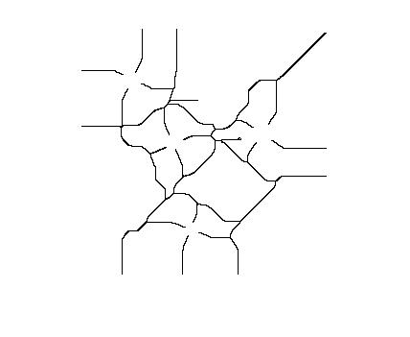

Phn1thr1original –

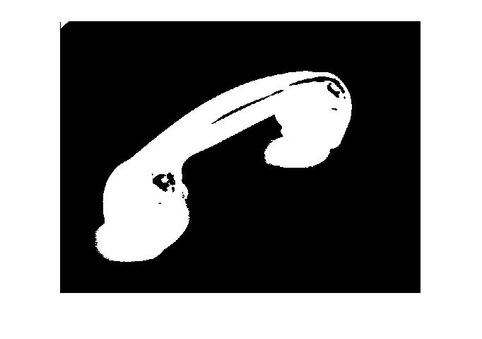

Bwmorph –

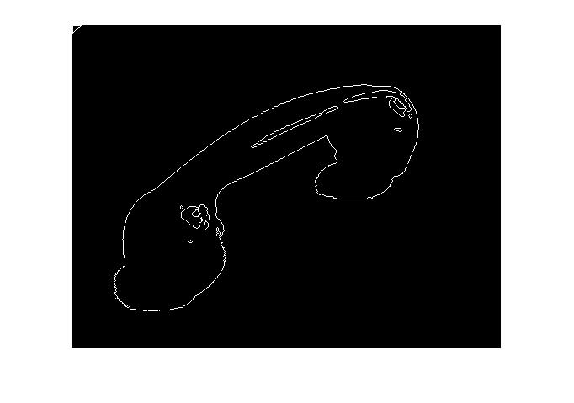

Thickening –

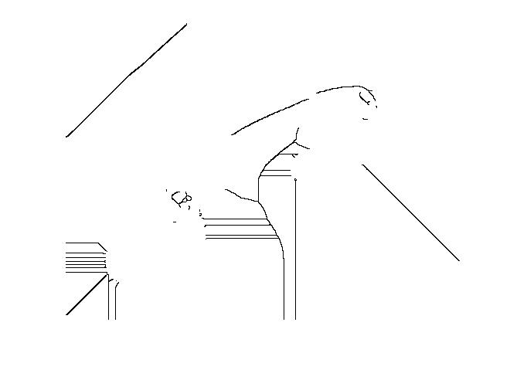

CODE –

%BW = imread('C:\Users\student\Desktop\morphologgy\Images basic-20191218\rectangle.png');

%se = strel('square',50);

%BW2 = imdilate(BW,se);

% Task 1, Dilation

%imshow(BW), title('Original')

%Task 2, Dilation

%figure, imshow(BW2), title('Dilated')

%BW = imread('C:\Users\student\Desktop\morphologgy\Images basic-20191218\rectangle.png');

%se = strel('square',50);

%erodedBW = imerode(BW,se);

% Task 1, Dilation

%imshow(BW), title('Original')

%Task 2, Dilation

%figure, imshow(erodedBW)

%Detect edges

%external = BW2- BW

%imshow(external)

%Gradient

%internal = BW- erodedBW

%imshow(internal)

%gradient = external + internal

%imshow(gradient)

%task 4 5

%art4 = imread('C:\Users\student\Desktop\morphologgy\Images basic-20191218\art4.png');

%wdg2 = imread('C:\Users\student\Desktop\morphologgy\Images basic-20191218\wdg2thr3.png');

%se = strel('square',10);

%closeBW = imclose(art4,se);

%figure, imshow(closeBW)

%se = strel('square',10);

%closeBW2 = imclose(wdg2,se);

%figure, imshow(closeBW2)

%task 6 & 7

%art2 = imread('C:\Users\lab\Desktop\mm\art2.png');

%se = strel('disk',3);

% con structing element so that all the lines from above image is gone

%se = strel('disk',10);

%afterOpening = imopen(art2,se);

%figure

%imshow(afterOpening,[]);

%task 9

%BW = imread('C:\Users\lab\Desktop\mm\art6.png');

%imshow(BW);

%BW2 = bwmorph(BW,'remove');

%figure, imshow(BW2)

%BW3 = bwmorph(BW,'skel',Inf);

%figure, imshow(BW3)

%BW = imread('C:\Users\lab\Desktop\mm\phn1thr1.png');

%imshow(BW);

%BW2 = bwmorph(BW,'remove');

%figure, imshow(BW2)

%BW3 = bwmorph(BW,'skel',Inf);

%figure, imshow(BW3)

%task 10

BW = imread('C:\Users\lab\Desktop\mm\thickening\art8.png');

imshow(BW);

BW2 = bwmorph(BW,'remove');

figure, imshow(BW2)

BW3 = bwmorph(BW,'thicken',Inf);

figure, imshow(BW3)